

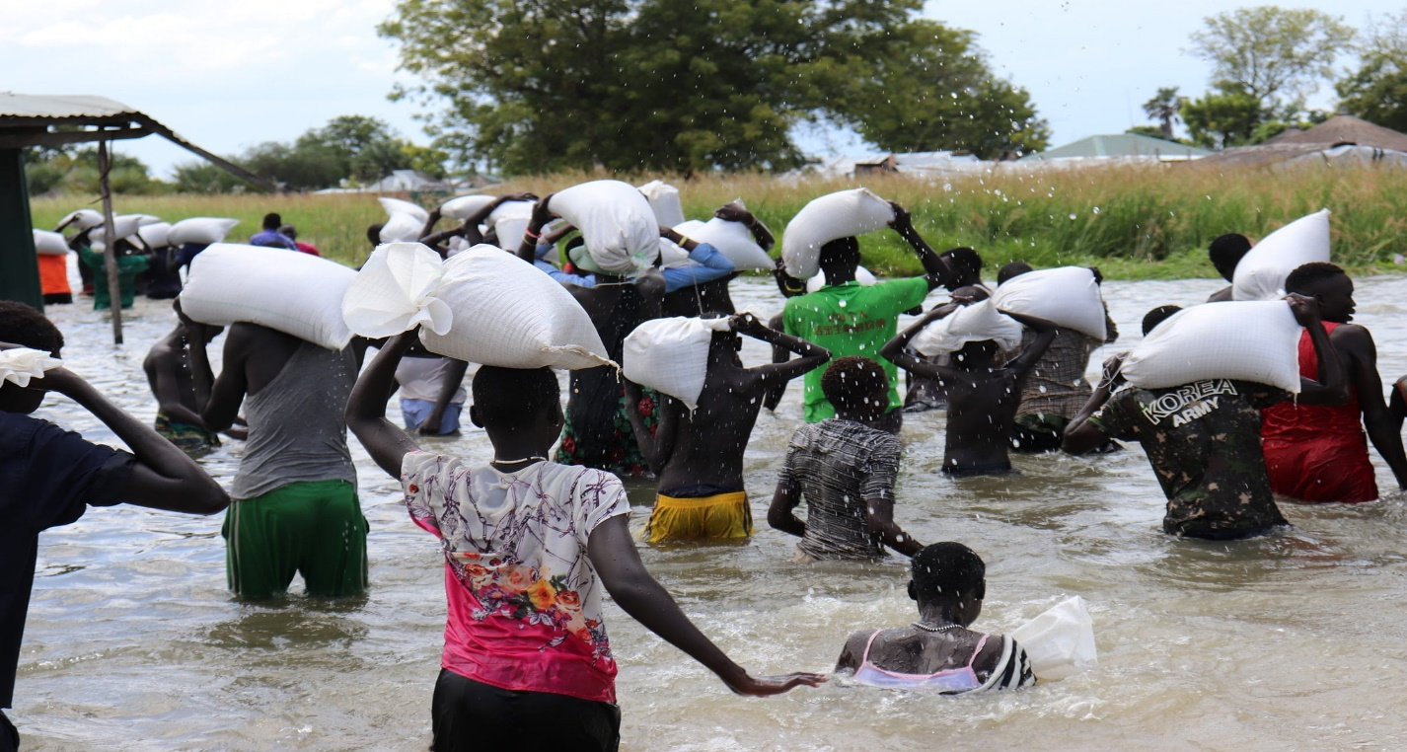**Community Empowerment for Progress Organization**

**Report**

**on**

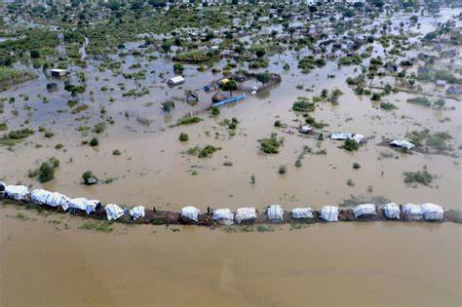Disability Inclusion During Flood Preparedness and Response in South Sudan

**August, 2024**

**Juba-South Sudan**

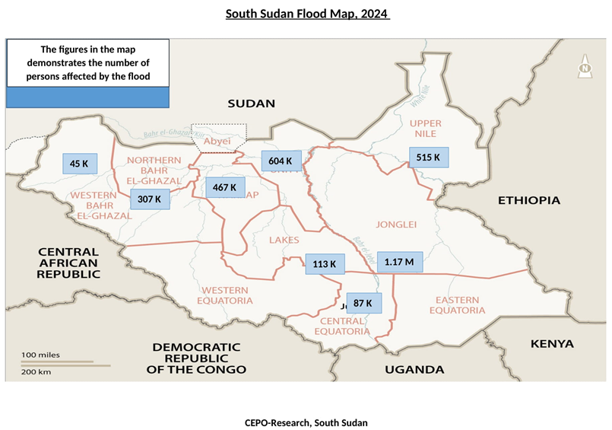

**Key**

*The figure shown in the map represent the number of population per state at risk of Flood shock this year June-December, 2024*

**Table of Content**

South Sudan Flood Map, 2024…………………………………………………………… 2

Table of Content …………………………………………………………………………….. 3

Acknowledgement ………………………………………………………………………….. 4

Executive Summary ………………………………………………………………………5-6

Methodology ………………………………………………………………………………. 7-8

Aim of the survey …………………………………………………………………………… 8

General Overview of the survey ………………………………………………………..8-9

Number of potential people to be affect and areas of higher threats and risks 10

Key finding principles ………………………………………………………………. 10-11

Recommendations and way forward ……………………………………………… 11-12

Conclusion …………………………………………………………………………………. 12

Reference ………………………………………..………………………………………….. 13

**Acknowledgement**

CEPO would like to appreciate and thank the team behind this small scale survey. The survey triggered consultative thinking around disability inclusion in flood preparedness and responses.

Further, appreciations go to the persons involved in the key informants’ interviews and your contribution have strengthened the content of this survey. At this point CEPO thanks all the enumerators and CEPO team that were involved in drawing analysis, finding principles and recommendations in simple manner

Finally, thanks go to everyone that has contribute in any form for the success of this small scale survey on disability inclusion in flood preparedness and responses in South Sudan

**Executive Summary**

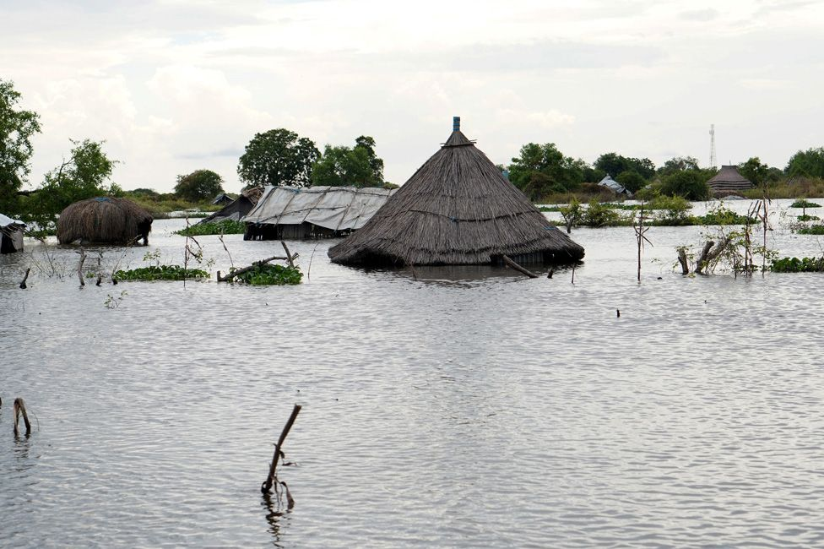Six states namely Jongeli, Upper Nile, Unity, Northern Bahr el Ghazal, Lake and Central Equatoria of South Sudan are badly affected by the floods for third consistent time without durable solutions offered by the government. It is estimated that the floods will affected.

The government of South Sudan has developed South Sudan flood preparedness and response plan for the period June-December 2024. CEPO reviewed the plan, it was realized that the plan has not strongly embrace disability inclusion. This made the flood inclusive preparedness and response bid difficult.

Persons with disabilities are the most affected section of the population faced by the floods shocks. The underling factors that made them as the most affected section of the populations are centered on the following factors;

1. ***South Sudan preparedness and response actions are less inclusive***
2. The detailed actions for responding lacks straight forward action on disability inclusion
3. The preparedness actions are not disability inclusive
4. ***Absence of key messages for persons with disabilities. Among the key required messages are;***
5. Reallocation of population to safe location including approach for the reallocation and the site for the reallocation
6. Institution(s) responsible for the reallocation of the population to high lands
7. Social services associated with the reallocation of the population
8. Means of mobility to the high lands/sites
9. ***Provisions of well trained personnel on mitigating issues of persons with disabilities in the floods***
10. Absence of sign language experts
11. Lack of inclusive means of passing key floods-related messages
12. ***. Inadequate media engagement on accurate reporting on safety and protection of persons with disabilities in the face of the floods***
13. Irregular media reporting on disabilities rights protection in the face of the flood
14. Some media lack the skills for accurate or correct use of language terminologies on rights of disabilities
15. ***Absence of proper aggregated data/statistics with specific figure on numbers of persons with disabilities***
16. Without a clear aggregated data/statistics that indicates numbers of persons with disabilities, any form of planning, preparedness and response may not be inclusive enough

These key findings among others demonstrates clearly that designers/planners of the country flood preparedness and response plan are lacking experts on disability inclusion. The plan was use for setting states committees on flood preparedness and response. Following these findings, it is essential to undertake some actions that address the gaps on disability inclusion observed. The key recommendations among others are;

1. *South Sudan preparedness and response plan implementation mechanisms should have disability inclusion experts*
2. *There is a need to train community workers on safety and protection of persons with disabilities in the face of the flood*
3. *There is need to create key messages for safety and protection of persons with disabilities in the flood*
4. *It is essential to provide well trained personnel on mitigating issues of persons with disabilities in the flood*
5. *It is paramount that data associated with flood should be aggregated into multi aspect and specifically figure for persons with disabilities for inclusive planning, preparedness and response*
6. *There is need to strengthen media engagement on accurate reporting on safety and protection of persons with disabilities in the face of the flood*

Finally, more efforts are needed for increasing and promoting disability inclusion in South Sudan flood preparedness and response plan. Disability inclusion is essential in South Sudan because South Sudan is now a state party to the United Nations Convention on the Rights of the Persons with Disability

1. **Background Information**

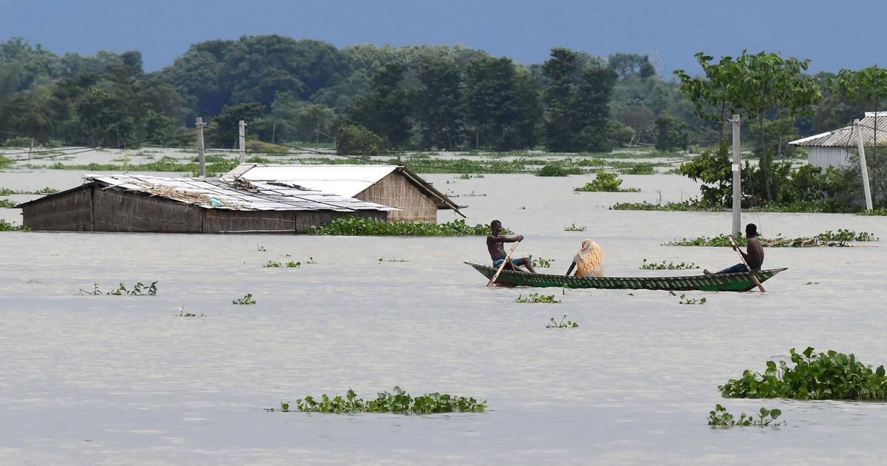This small scale survey was a desk review study and limited filed facts verification through method of key informants interview on matters associated with safety and protection of rights of persons with disabilities in the face of the flood in accordance to article 11(1) of the United Nations Convention on the Rights of Persons with Disabilities (UNCRPD). South Sudan is already a state party to the UNCRPD**[1]** since 24th February, 2024 and officially South Sudan was urged by the Secretary General of United Nations to enforce UNCRPD from 6th March, 2024 after successful deposition of the UNCRPD. The desk review mainly focuses on the developed government strategies and plans for flood preparedness and responses at national and state levels.

The trigger for this small scale desk review survey was the observation of inadequate messaging on matters or needs of persons with disabilities. Additionally, the language used in the strategies and plans is not disability inclusion focused. This has made the safety and protection of the persons with disabilities at greater risk and threats.

South Sudan on 6th March, 2024 officially is a state party to the United Nations Convention on the Rights of Persons with Disabilities. Article 11 of the UNCRPD requires state party to undertake effective inclusion preparedness and response to ant humanitarian crisis such as flood. It is clear that still majority of the government officials are not well informed about the requirements of the UNCPRD and its optional protocol. This made a lot of the government plans, strategies and approaches on public interest matters are not embracing disability inclusion as required.

1. **Methodology**

The approach for generating this small survey data was desk review with limited key informant interviews. The methodology was designed with an aim of building factual narrative for commissioning of in-depth research study on Disability Inclusion in the Flood Preparedness and Response.

* 1. **Desk Review**

The desk review mainly focuses on the following documents;

1. South Sudan Flood Preparedness and Response Plan, June-December, 2024
2. Established states flood response committees’ plans
3. Media reports/articles. Over 10 various media articles were reviewed on use of correct terminologies
4. Publications and reports online on matters of disability inclusion
   1. **Key Informants Interviews**

The key informant interview mainly focuses on leaders of institutions that have direct role in flood preparedness and responses including selected leaders in organizations of persons with disabilities. The sample size of the key informants interview is 2,300 persons form the six most affected states by the flood.

1. Leaders of organizations of persons with disabilities in selected locations
2. Head preparedness and responses committee in national and state levels
3. Selected County Commissioners
4. **Aim of the Survey**

This survey is intended to deliver the following results below;

1. To establish facts on disability inclusion during flood preparedness and response
2. To amplify the importance of disability inclusion during flood preparedness and response
3. To generate accurate information for advocacy and lobby on disability inclusion
4. **General Overview of the survey**

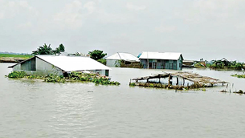Flooding in South Sudan created multiple shocks to human lives. Among the key shocks are diseases, food insecurity, violence related to competition over highland for human, livestock and farming use, gender based violence for the last three years in the affected states. In 2024, UN health agency (WHO in South Sudan) warmed[2] as quoted “*Severe flooding, recurrent violence, weak governance, poverty and lack of infrastructure have created a complex humanitarian crisis which is hindering South Sudan’s development*”

Among the selection of the society that are more than double facing the flood shocks are persons with disabilities. It is clear that disability inclusion in the flood preparedness and responses is not taken serious by the institutions of government and Non-governmental institutions. Evidently, this survey found out that use of the language in all writings of the documents on flood preparedness and response never embrace disability inclusion. Only the phrase of persons with disabilities is mentioned in the list of defining the most vulnerable category of the society in the face of flood shocks. Here is an example quoted “*A staggering 8.9 million people mostly in flood and conflict-affected areas have been affected, with women, children, the elderly and people with disabilities at higher risk” this is within the expressed warms[3] of WHO-UN”*

South Sudan population figures that are to be use for flood preparedness and responses should be properly aggregated with specific focus on figures of persons with disabilities. Data is very important for any accurate and functional planning or strategy designing in any form of shocks preparedness and responses. The survey realized that the absence accurate data on persons with disabilities has contributed in missing of public messaging on disability inclusion in the hole South Sudan Flood Preparedness and Response Plan for June-December 2024 besides the stronger call made in article 11 (1) of the United Nations Convention on the Rights of the Persons with Disabilities as quoted “*States Parties must take necessary measures to ensure the protection and safety of persons with disabilities in situations of risk, including armed conflict, humanitarian emergencies, and natural disasters*”[4]. South Sudan is state party to the United Nations Convention on the Rights of the Persons with Disabilities and its Optional Protocol since 6th March, 2024.

During the survey engagement on desk review, it was realized that already good work in directing inclusive flood preparedness and response was developed by multiple institutions that specifically worked on disability inclusion in humanitarian situation or beyond. **[5]**Christian Blind Mission (CBM) International, Humanity & Inclusion (HI) and the International Disability Alliance (IDA) have done remarkable work Inclusion of persons with disabilities in humanitarian action through CASE STUDIES COLLECTION 2019 from 39 examples of field practices, and learnings from 20 countries, for all phases of humanitarian response

South Sudan government and Non-governmental agencies engaging in the development of the Flood Preparedness and Response should take action of involving the specialized organization on inclusion such as CBM International, Humanity & Inclusion, Light for the World among others for genuine development of inclusive Flood Preparedness and Response Plan

This survey has triggered consultative thinking on disability inclusion in flood preparedness and responses in South Sudan. Facts were generated indicating that much efforts are need for genuine realization of disability inclusion in flood preparedness and response. The establish various flood preparedness and response committees at national and state levels are required to serious undertake actions for disability inclusion. It is requirement by the article 11(1) of the United Nations Convention on the Rights of the Persons with Disabilities and its optional protocol which South Sudan is a state party to it.

1. **Number of potential people to be affected and areas of higher threats and Risks**

Multiple sources of reports indicated that the period from September to December, 2024 the flood with sever and most dangerous to the population of the areas of high risk and threats of flood shocks. With direct quoting or referencing to liable information on projecting number of population and areas at risk of the flood shocks as below;

*“More than 2,000,000 people will likely be affected, and approximately 1,200,000 individuals are expected to be displaced and in dire need of humanitarian assistance.Massive flooding is expected in the following areas:*

1. ***Five Counties of Jonglei State*** *(Bor South, Twic, Duk, Uror, Fangak)*
2. ***Six counties of Unity state*** *(Rubkona, Guit, Leer, Mayandit, Pariang, Panyinjiar)*
3. ***Four counties of Upper Nile state*** *(Kodok-Fashoda, Maban, Malakal, Renk)*
4. ***Three counties of the GPAA*** *(Pibor, Lokuankeley, Pochala)*
5. ***Great Administrative Areas*** *of Abyei and Rueng*
6. ***Two counties of Central Equotoria*** *(Terekeka, Juba County)*
7. ***Northern Bhar–El–Gazal*** *(Aweil center, Aweil East South of Abyei)*
8. ***Three counties of Lake State*** *(Awerial, Yirol East, Cuibet)*

*The impact of flooding in 2024 is likely to be compounded by ongoing insecurity and conflict, previous consecutive flooding incidents, limited access to basic services, and high levels of food insecurity. Several consecutive years of the above listed challenges and flooding have resulted in long-term displacement and complex humanitarian conditions in most of the above listed at risk areas. The cost-of-living crisis will also exacerbate pre-existing vulnerabilities”.* ***Sources:***[South Sudan: Imminent floods - DREF Operation (MDRSS014) - South Sudan | ReliefWeb](https://reliefweb.int/report/south-sudan/south-sudan-imminent-floods-dref-operation-mdrss014)

In relation to disability inclusion on matters of data, it is very harder almost difficult to get aggregated data where specific numbers of persons with disabilities is properly mentioned. This is a big gap in data for strengthening and embracing disability inclusion during the flood preparedness and response

1. **Key Finding Principles**
2. South Sudan Flood Preparedness and Response Plan for June-December, 2024 is not disability inclusion enough
3. The mechanisms or institutions tasked for implementing the South Sudan Flood Preparedness and Response Plan should have disability inclusion experts
4. South Sudan Flood Preparedness and Response Plan have not specific messages on needs of persons with disabilities
5. Media coverage on safety and protection of persons with disabilities in the face of the flood is inadequate
6. No preparation for equipping community volunteers for rescues of persons with disabilities who may be facing risks and threats in the flood
7. Statistics on population at risk of the flood shock is not properly aggregated to the level that it can show figure of persons with disabilities at risk
8. Due to lack of clear aggregated data/statistics, there is high possibility that any form of responses such as humanitarians, prevention of gender based violence among others may not be inclusive enough
9. The inadequate inclusive public messaging on flood preparedness and response, has made the persons with disabilities less vocal or out speaking on their safety and protection
10. Absence representation and participation of persons with disabilities in flood preparedness and response institutions created inadequate disability inclusion
11. **Recommendations**

Good example of guiding principles, strategies and manuals developed for disability inclusion in flood or any other humanitarian shock preparedness and response are available online and use as reference in this survey findings. It is sense of responsibility and duty to deliver inclusion in any humanitarian situation preparedness and response such as the flood in South Sudan in accordance with article 11 (1) of the UNCRPD and its optional protocol. For genuine and practical recommendations and way forwards from the survey, below are the proposed options of recommendations and way forward;

1. It is essential that usage of official developed guidelines, strategies and manuals on disability inclusion during flood or any humanitarian disaster situation preparedness and responses
2. There is a need for the South Sudan Flood Preparedness and Response Plan for June-December, 2024 to embrace disability inclusion
3. The mechanisms or institutions tasked for implementing the South Sudan Flood Preparedness and Response Plan, 2024 should have disability inclusion experts
4. South Sudan Flood Preparedness and Response Plan, 2024 should have specific messages on needs, safety and protection of persons with disabilities
5. It essential to support media coverage on needs, safety and protection of persons with disabilities in the face of the flood
6. There is a need to have effective training of community volunteers for rescues of persons with disabilities in the flood
7. Availing statistics on population of persons with disabilities at risk of the flood shock is paramount
8. All data associated with flood preparedness and response should be properly aggregated to the level that it can show figure of persons with disabilities at risk including potential risk of gender based violence and conflict
9. There is a need to have adequate inclusive public messaging on flood preparedness and response to motivating persons with disabilities to be vocal or out speaking on their safety and protection
10. **Way forward**

CEPO with direct collaboration with the relevant government institutions among the key are Ministry of Humanitarian Affairs and Disaster Management, Ministry of Gender, Child and Social Welfare and other ministries including organizations of persons with disabilities, development partners on disability inclusion and media will immediately undertake the following tasks/actions below;

1. Immediate development of an inclusive flood preparedness and response advocacy and lobby plan for strengthening safety and protection of persons with disabilities during the flood shocks.
2. In collaboration with the Government Ministry of Humanitarian Affairs and Disaster Management, Organizations of Persons with Disabilities including other partners on disability inclusion will organize national roundtable on Disability Inclusion in Flood Preparedness and response
3. Undertake actions with various media houses and media organizations for amplifying of voices of persons with disabilities in the states through inclusive public messages and radio talk shows
4. Lobby our national parliamentarians (lawmakers) to raise a motion for discussion on safety and protection of persons with disabilities in the face of the flood
5. Influence any budgetary process related to the flood preparedness and response to be inclusive and transparency of the inclusivity of the budgets operations are required to be made public

1. **Conclusion**

This small scale survey through desk review and limited key informant interviews was designed to generate evidence for strengthening our advocacy and lobby for disability inclusion in South Sudan flood preparedness and response. The survey generated clearly facts that require more in-depth research on the disability inclusion in flood preparedness and responses at all levels of the government.

Flood negative implication on the population of persons with disability in South Sudan is real and requires adequate preparedness and responses including inclusive public messaging on all sectors of response. The survey results will be follow up by in-depth research within the period of the South Sudan flood preparedness and response plan June-December 2024.

Effective and influential advocacy and lobby for disability inclusion will be developed for implementing the results of this small scale survey. The survey came out with practical and implementable recommendations for way forward on strengthening disability inclusion in flood preparedness and response in the flood affected states of South Sudan.

**References**

South Sudan Flood Preparedness and Response Plan, June-December 2024 ([South Sudan Floods Preparedness and Response 22 June 2024.pdf (fscluster.org)](https://fscluster.org/sites/default/files/South%20Sudan%20Floods%20Preparedness%20and%20Response%2022%20June%202024.pdf)

South Sudan: Humanitarian Situation Monitoring - Prospective areas of destination in the event of flooding, June - July 2024 ([South Sudan: Humanitarian Situation Monitoring - Prospective areas of destination in the event of flooding, June - July 2024 - South Sudan | Relief Web](https://reliefweb.int/report/south-sudan/south-sudan-humanitarian-situation-monitoring-prospective-areas-destination-event-flooding-june-july-2024))

South Sudan Complex Emergency Fact Sheet ([2024-08-12_USG_South_Sudan_Complex_Emergency_Fact_Sheet_5.pdf (usaid.gov)](https://www.usaid.gov/sites/default/files/2024-08/2024-08-12_USG_South_Sudan_Complex_Emergency_Fact_Sheet_5.pdf)

Inclusion of persons with disabilities in humanitarian action ([Inclusion of persons with disabilities in humanitarian action. Case studies collection 2019 (interagencystandingcommittee.org)](https://interagencystandingcommittee.org/sites/default/files/migrated/2019-12/Case%20studies%2C%20Inclusion%20of%20persons%20with%20disabilities%20in%20humanitarian%20action%2C%202019.pdf)

Guidance on strengthening disability inclusion in Humanitarian Response Plans (Guidance_on_strengthening_disability_inclusion_in_Humanitarian_Response_Plans.pdf)

Key Recommendations for Inclusive Practise in this thematic area for WFP inclusion in this ([WFP-134215](https://executiveboard.wfp.org/document_download/WFP-134215))

**Media Articles**

Radio Tamazuj articles on flood ([You searched for Flood South Sudan - Radio Tamazuj](https://www.radiotamazuj.org/en?s=Flood+%20South%20Sudan))

Eye Radio articles on flood ([You searched for Flood - Eye Radio](https://www.eyeradio.org/?s=Flood+))

Sudans Post articles on flood ([You searched for Flood – Sudans Post](https://www.sudanspost.com/?s=Flood+&tztc=1))

1. [Disability Rights are Human Rights: from Ratification to | IOM South Sudan](https://southsudan.iom.int/stories/disability-rights-are-human-rights-ratification-implementation-crpd)
2. [South Sudan faces growing humanitarian crisis, warns WHO | UN News](https://news.un.org/en/story/2024/07/1152106)
3. [South Sudan faces growing humanitarian crisis, warns WHO | UN News](https://news.un.org/en/story/2024/07/1152106)
4. [article 11 of UNCRPD - Search (bing.com)](https://www.bing.com/search?pglt=41&q=article+11+of+UNCRPD&cvid=b668286577d44558b5a8747a4624e44c&gs_lcrp=EgZjaHJvbWUyBggAEEUYOTIGCAEQABhAMgYIAhAAGEAyBggDEAAYQDIGCAQQABhAMgYIBRAAGEAyBggGEAAYQDIGCAcQABhAMgYICBAAGEDSAQkxMDA4NmowajGoAgCwAgA&FORM=ANNTA1&PC=U531)
5. [Inclusion of persons with disabilities in humanitarian action. Case studies collection 2019 (interagencystandingcommittee.org)](https://interagencystandingcommittee.org/sites/default/files/migrated/2019-12/Case%20studies%2C%20Inclusion%20of%20persons%20with%20disabilities%20in%20humanitarian%20action%2C%202019.pdf)