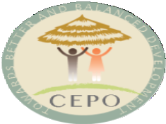

COMMUNITY EMPOWERMENT FOR PROGRESS ORGANIZATION
West of Equatoria Tower, Women Union Compound-Hai Neem, Juba- South Sudan
Website: www.cepo-southsudan.org

Press Release 20TH May, 2026

Youth Action for Peace (YAP)

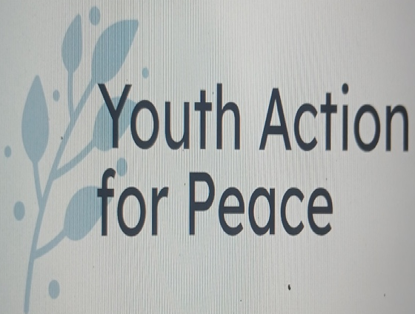
Juba,20thMay,2026-Community Empowerment for Progress Organization (CEPO) is pleased to inform the public that it has initiated program that aim at empowering youth for driving peace agenda in the face of the country political instability and the continue military confrontation among the armed opposition groups. This program is within the framework of citizens talk for peace. The initiative will be a nationwide youth engagement for fostering peace and mitigating all forms of violence in accordance with the United Nations Security Council Resolution 2250 on Youth, Peace and Security. The program will be bringing the youth to the center of the agendas on peace and security for securing political stability. Placing youth at the center of the decision making is a key aspect of this initiative

Mr. Edmund Yakani, Executive Director of CEPO says the initiative will be administer by youth themselves as peace ambassadors across the country through established secretariat for Youth Action for Peace. The leaders from bring this initiative will be youth at age of 15 to 35 years old across the county. The secretariat for the Youth Action for Peace will embrace inclusivity and diversity, consultative dialogue and local solutions for durable peace and stability. among the key activities of the Youth Action for Peace (YAP) will knowledge and skills transfer and sharing, organization of National Youth Peace Camps, holding sessions with lawmakers, regaining trust and confidence, healing, reconciliation, trauma healing, truth-telling and facilitation of consultative dialogues. Non-violence approach shape all interventions of the YAP
Finally, CEPO is urging all youth across the country is get ready and prepared for effective engagement in YAP activities and events for nurturing peaceful South Sudan and building culture of non-violence and peaceful co-existence among our communities. YAP will be fully collaborating with the relevant national, states and administrative areas institutions for effective success.

Email: ceposouthsudan@gmail.com

