

Community Empowerment for Progress Organization

Pre-Elections Domestic Observation
3rd Report

16th June, 2026
Juba

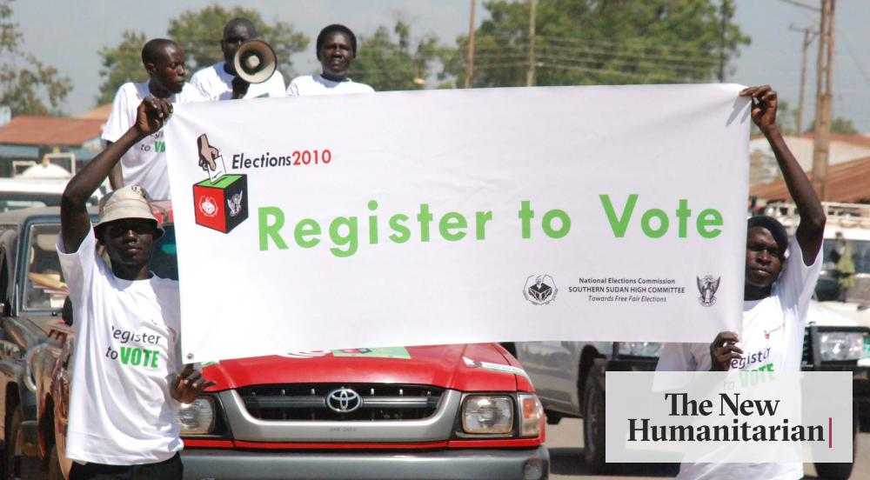

Executive Summary
South Sudan is struggling to administer elections in December 2026 as the concluding political exercise for transitioning the country from violence to peace through the implementation of the 2028 peace agreement. The truth on the road to elections is that political consensus and commitment is absolute undermine by the high deficit in trust and confidence among the political decision makers in various public institutions that were tasked to prepare the country for elections. Politicking that is fueled by the historical political-related mistrust and limited confidence has a stronger influence on the process of making decisions for the conduct of the elections scheduled for 22nd December, 2026.
Evidently, the impacts of that negative politicking have made the National Elections Commission not timely and adequately funded for delivering tasks that create a conducive environment for the holding of the December 2026 elections. Although lately some funds were transferred to the National Elections Commission but heavy pressure and advocacy at a late time. Due to the slow and delayed transfer of funds to the national elections tasked institutions, namely the National Elections Commission, Political Parties Council, and National Constitutional Review Commission, including National Police Services, all their essential tasks for creating a conducive environment for the scheduled elections in December 2026 were delayed. This trend has generated a lot of doubts and the setting of preconditions from multiple actors, including citizens, political parties, regional and international friends of South Sudan. The critical challenges before the leadership of the country are both political and financial support for the electoral processes. The key and necessary deadline set by the legal framework for the elections is approaching faster, and the deadlines are placing the national institutions with an election mandate at real risk. Among the key deadlines required by the legal framework is on 22nd June, 2026, the National Election Commission should publish the final list of the registered voters for the elections, and at the same time announce the elections calendar for December 2026. Eight days after 30th June, 2026, the Political Parties Council is required to hand over the legally registered parties to the National Elections Commission. All these deadlines are too close to be met by the relevant institutions. The only available opportunity for a better setting of the process, the government should trigger the implementation of Resolution 6 of the recent African Union Ad Hoc Committee known as AU C-5 plus declaration dated 15th February, 2026.
- Introduction
This report is a pre-election domestic observation report generated through the desk review method. This is the third issue of CEPO Pre-Elections Domestic Observation. Elections were agreed upon by the party’s signatories to the 2018 peace agreement as a process for the honorable and peaceful transfer of power from one political group or individual.
Elections that are required by the framework of the 2018 peace agreement provisions are strategic, but it demands serious and genuine political commitment from the leadership of the country. The country's preparedness for the scheduled elections on 22nd December 2026 is badly muddled by the political leadership due to high deficit among the top political leaders of the country. The South Sudan road to elections scheduled for 22nd December 2026 is getting more impossible and harder to address and handle
Pre-election domestic observation is a very important exercise for building early warning information and pointing out some of the potential threats to the election’s credibility and non-violent nature. The situation of South Sudan is politically challenging since reaching a political compromise and consensus is not among the political actors. The trend of no easy making of political compromise and consensus among the political actors is a potential trigger for violent and deadly elections.

- Methodology
This report is generated from a desk review exercise and limited key informants’ interviews that were directed to influential leaders with connections to electoral planning and administration. The desk review undertakes analyses of documents officially published in public media outlets or officially issued by legal entities.

- Purpose of this report
To provide early warning information in the face of country preparation for scheduled elections on 22nd December 2026

- Key Findings
- Political commitment to transitioning the country from violence to peace through elections is getting more impossible.
- The current legal inquiries associated with the electoral legal framework require urgent political answers/clarities before 22nd September, 2026
- The legal concerns of some communities associated with the use of the 2010 constituencies require answers or resolutions.
- Before 22nd December, 2026, the question of what type of elections needs an urgent answer for establishing accurate vote information
- The status of the political parties’ registration before 22nd December 2026 is critical and essential to be finalized before the rollout of the election campaign.
- Critical election deadlines are posing real political challenges on the path to holding elections on 22nd December 2026
- The process raised by the resolution number 6 of the recent AU C-5 plus Declarations as quoted “DIRECT the AU Commission to coordinate and collaborate with the relevant institutions of RTGoNU to develop a clear roadmap for elections and to provide technical and financial support to create conducive environment for the organization of the free, credible and inclusive elections in December 2026 inclusive of all citizens eligible to participate in the elections;” is critical in moving forwards with the conduct of the elections scheduled for 22nd December, 2026
- A potential threat to restricting civic and political space is surfacing now through the recent letter of RRC dated 8th June, 2026, warning all registered associations under RRC not to get involved in political activities.

- Conclusion
The expected forthcoming 22nd December, 2026 elections are facing technical key challenges associated with legal constraints and delayed political leadership decisions on paving the pathway for peaceful and credible elections. The development of an official state warning issued by RRC dated 8th June, 2026, the warning said: “all registered associations with RRC in South Sudan should abstain or avoid involvement in political activities”.
This warming is threatening and limiting the role of the associations in civic education for mobilizing citizens for meaningful and effective participation in the forthcoming elections in December 2026. With an increase in restricting civic and political space before the December 2026 elections, the public and political actors’ participation may be below standard, and this may trigger electoral violence to undermine peaceful elections. The country's preparation for the elections requires proper and genuine political commitment that makes all actions towards holding the elections non-violent and embrace standards of credibility.

https://www.eyeradio.org/elections-commission-says-only-4-of-funds-released-for-december-elections/
https://www.eyeradio.org/kiir-pledges-resources-for-december-2026-elections/
https://www.eyeradio.org/s-sudan-monitor-doubts-2026-elections-over-funding-delays/#google_vignette
https://www.eyeradio.org/us-envoy-says-support-for-2026-elections-hinges-on-peaceful-conditions/
Key Informant Interviews covered 50 persons
RRC= Relief and Rehabilitation Commission. Government institution responsible for the legal registration of Associations

