

COMMUNITY EMPOWERMENT FOR PROGRESS ORGANIZATION
West of Equatoria Tower, Women Union Compound-Hai Neem, South Sudan

SOUTH SUDAN WEATHER EARLY WARNING
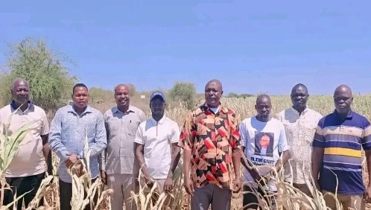

Drought Conditions Threaten Agriculture in South Sudan
Several parts of South Sudan are experiencing increasingly dry conditions, creating serious challenges for the agricultural sector. August and September 2026 have been marked by below-normal rainfall in some areas, with dry conditions expected to persist into October, according to forecasts from the IGAD Climate Prediction and Applications Centre (ICPAC).
The prolonged dry conditions are already affecting communities, crops, livestock, and water availability, with some areas of Eastern Equatoria reportedly among the hardest hit.
However, the October–December period could bring a different challenge, with forecasts indicating the possibility of heavier-than-normal rainfall in some areas. Such rainfall could increase the risk of flooding, potentially resulting in the destruction of crops, loss of livestock, damage to infrastructure, and displacement of communities.

Immediate Local Recommendations for Farmers
To reduce the impact of the current dry conditions and prepare for possible flooding, communities and farmers can consider the following measures:
- Plant vegetables near swamps and riverbanks where sufficient moisture is available, while avoiding areas at high risk of flooding. Where appropriate, farmers can also use raised planting beds or planting pits.

- Use irrigation where water sources are available and safe to use.
- Plant short-season crops that can mature within a shorter period and require less water.
- Use drought-tolerant crops and varieties, such as cassava, sweet potatoes, and yams, where suitable for the local environment.
- Conserve available food supplies. Households should avoid selling all their available food stocks and should retain sufficient reserves for household consumption.
- Use mulching. Cover the soil around crops with dry grass, leaves, or other suitable organic materials to help retain soil moisture and protect plant roots from excessive heat.
- Prepare for possible flooding. Farmers should avoid planting in low-lying areas that are likely to be flooded and should protect livestock, seeds, tools, and other agricultural assets where possible.

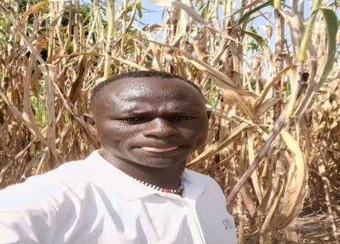
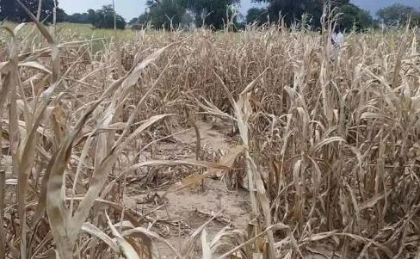
Overall, communities need to prepare for both extremes: prolonged dry conditions in the short term and possible heavy rainfall and flooding later in the year. Local authorities, farmers, humanitarian organizations, and agricultural extension workers should strengthen early-warning information and support communities with practical climate-adaptation measu

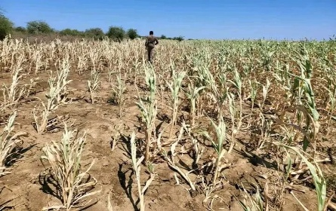
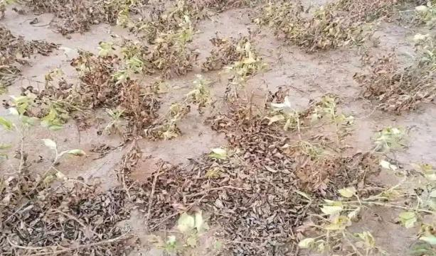

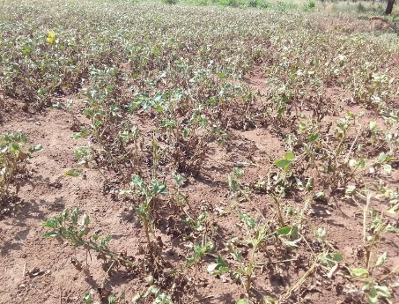
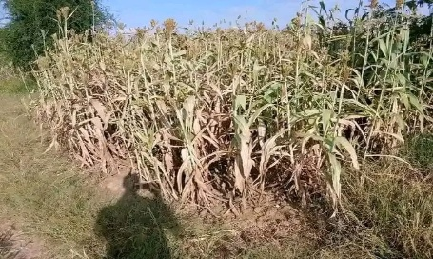
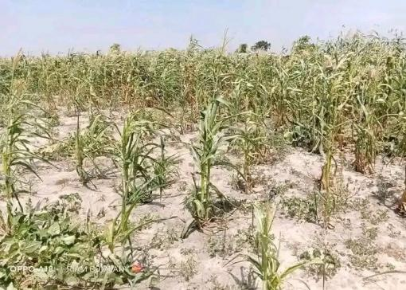

Photos of crops affected by drought in Eastern Equatorial, Central Equatorial, and Bahr El Ghazal States

Prepared by: Bidali Peter Elias
Project Officer
CEPO

