
Community Empowerment for Progress Organization

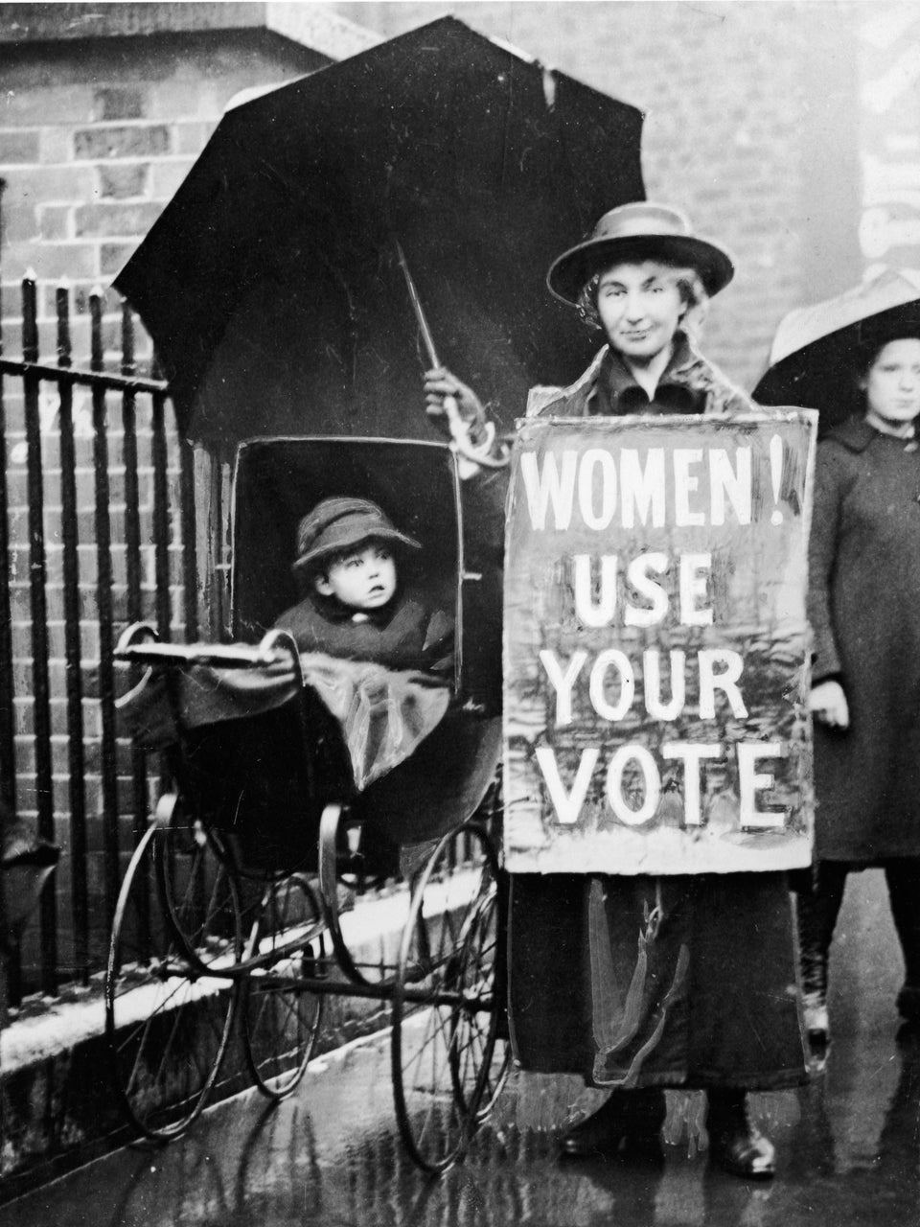
Brief Pre-Elections Domestic Observation

Women and Voters Registration in South Sudan's December 2026 Elections

4th November, 2026

Executive Summary
Women's access to accurate voter registration information has a direct, heavy impact on the matters of women and elections. The forthcoming South Sudan December 2026 elections have to be purposely made so that women's access to accurate voter registration is made a priority for securing meaningful women's participation and representation in the electoral process. The setup of the women's day-to-day style of engagement has an effective role in limiting women's access to accurate information; due to this, it is essential that intentional efforts are made to strengthen women's access to accurate voter registration information.
The dominance of males in the electoral process made the women turning out as voters and candidates below expectations. For this reason, it is essential that strategies and approaches are adopted early enough to increase women's access to accurate voter registration information.
Without meaningful women supporters turning out as eligible voters through registration, the chance of winning meaningful women's participation and representation in public life through elections is limited. This is a point that should motivate all supporters of women candidates in the electoral process to turn out as eligible voters in a timely manner. Election results are determined by supporters turning out as eligible and accurate voters. It is essential that political parties and candidates invest a lot in ensuring that all their supporters are registered as eligible voters and turnout is accurate.
CEPO pre-election domestic observation on the subject of women and voter registration identified the following concerns below, which are detailed in the key findings:
- Women as voters and candidates require access to information timely and accurately
- Women candidates should help to turn their supporters into eligible and informed voters.
- Women candidates' supporters require proper mobilization for meaningful engagement in the electoral process and especially the stage of voter registration and correct casting of ballot paper.
- Women candidates' campaign agents should be trained on how to strengthen women's candidate election campaign messages that attract votes from voters.
- Women candidates should be properly oriented on how to use media and public event spaces for championing the election agenda for winning votes.
Our brief pre-election domestic observation findings demonstrate that if no intended efforts are deployed for strengthening the women and elections agenda at all stages of the electoral process, there is limited chance for women to register as progressive in the forthcoming elections for voters and candidates.
- Methodology
This pre-election domestic observation report was generated through desk review and a small sample of key informant interviews from institutions tasked with the electoral process and some women candidates with their supporters who are likely to turn into voters.

- Key findings
- Women candidates and their supporters are less informed on the importance of voter registration information.
- Women candidates have limited experience in turning supporters into determinate and correct voters
- Women candidates should be informed to prioritize their effective media engagement in the face of the electoral stage of voter registration.
- Women aspirants should be identified and trained on the importance of voters’ registration, including exposure to the skills of turning supporters to determine and correct voters.
- The upcoming face of voter registration is critical for the women aspirants/candidates in terms of gaining supporters for winning votes.
- Women candidates that intended to engage in elections through geographical constituencies should be prioritized for effective training.
- Women candidates who decided to face electoral voting through the women list or party list should be extra careful about the listing numbering since the votes will be subjected to percentage gained for allocating seats.
- Conclusion
Voter registration information is key for securing the turnout of supporters to determine and correct voters. Voter registration matters for setting the rights foundation for winning elections. Elections contesting candidates and campaigns generally pay close attention to communities with high voter registration and turnout rates. It is critical for the women contesting candidates to ensure that accurate voter registration information is provided to their actual supporters, who are necessary to turn out for registration to secure voting rights.
It is the primary duty of any candidate. Making meaningful progress toward diversity and parity in politics as well as in all positions of leadership and sectors of society depends on our continued pressing supporters to register as voters and have voter turnout determinately and vote correctly in the political participation. Now, with the rights and freedoms of women and other underrepresented communities on the line, as well as so many other critical issues at stake that impact the future of our democracy and the planet, it’s more important than ever to make our women voices heard and vote.

